**Project 3 Part 3 (full recursive approach O(nlog^2n))**

Name: ____Joshua Hsueh________________________ Period: ____3________

Date: _____11/20/2020___________________

Is your lab name l033?(lowercase L followed by digits 033) _____Yes______

Did you created a class to store a point? ___Yes________

Did you use a vector to store the points you generated? ____Yes_______

Did you use at least one iterator to traverse the vector you created? ___Yes________

Did you sort using the sort method offered by C++? ____Yes_______

Did you use at least one iterator to traverse the vector you created? ___Yes________

Does your main contain only 2 calls of: part2() and part3() (NO part1!!)? _____Yes______

(in main you may also have the part to display results for the 2 methods and them also in the txt file)

1. **Paste here a clear picture of the graph that compares the running times of the “initial recursive” algorithm and “full recursive” algorithm versus number of points. (use 2 different colors for the 2 graphs, colors that can be visible even if you print in black and white). Each point on this graph should be an average of several runs for that size:**

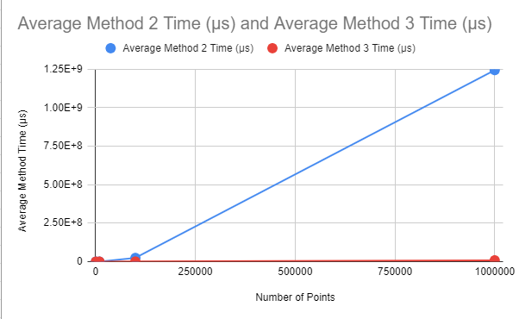

1. **Paste here the content of the results.txt when you run your lab on the content of the file points10k.txt and points100k.dat**

**For 10k:**

**Part 2: (0.49999999999999883426582414,0.50000000000000033306690739) , (0.49999999999999888977697537,0.50000000000000033306690739)**

**Distance: 0.00000000000000005551115123**

**Time: 171229.0 microseconds**

**Part 3: (0.49999999999999883426582414,0.50000000000000033306690739) , (0.49999999999999888977697537,0.50000000000000033306690739)**

**Distance: 0.00000000000000005551115123**

**Time: 70991.0 microseconds**

**For 100k:**

**Part 2: (0.49999999999973127051688948,0.49999999999889993551605016) , (0.49999999999975941467056373,0.49999999999890892832254963)**

**Distance: 0.00000000000002954596342610**

**Time: 23981574.0 microseconds**

**Part 3: (0.49999999999973127051688948,0.49999999999889993551605016) , (0.49999999999975941467056373,0.49999999999890892832254963)**

**Distance: 0.00000000000002954596342610**

**Time: 606985.0 microseconds**